***Mobile App 2***

**Classwork 1 : Constraint Layout Demo**

* **Xml file :**

<?xml version="1.0" encoding="utf-8"?>  
<androidx.constraintlayout.widget.ConstraintLayout xmlns:android="http://schemas.android.com/apk/res/android"  
 xmlns:app="http://schemas.android.com/apk/res-auto"  
 xmlns:tools="http://schemas.android.com/tools"  
 android:layout_width="match_parent"  
 android:layout_height="match_parent"  
 tools:context=".MainActivity">  
  
 <ImageView  
 android:id="@+id/imageView"  
 android:layout_width="0dp"  
 android:layout_height="0dp"  
 android:layout_marginStart="8dp"  
 android:layout_marginTop="36dp"  
 android:layout_marginEnd="8dp"  
 android:layout_marginBottom="24dp"  
 app:layout_constraintBottom_toTopOf="@+id/button3"  
 app:layout_constraintEnd_toEndOf="parent"  
 app:layout_constraintHorizontal_bias="0.0"  
 app:layout_constraintStart_toStartOf="parent"  
 app:layout_constraintTop_toBottomOf="@+id/textView"  
 app:layout_constraintVertical_bias="1.0"  
 app:srcCompat="@drawable/galaxys6" />  
  
 <TextView  
 android:id="@+id/textView"  
 android:layout_width="wrap_content"  
 android:layout_height="wrap_content"  
 android:layout_marginStart="16dp"  
 android:layout_marginTop="8dp"  
 android:layout_marginEnd="16dp"  
 android:text="Samsung Gallaxy S6"  
 app:layout_constraintEnd_toEndOf="parent"  
 app:layout_constraintStart_toStartOf="parent"  
 app:layout_constraintTop_toTopOf="parent" />  
  
 <Button  
 android:id="@+id/button"  
 android:layout_width="wrap_content"  
 android:layout_height="wrap_content"  
 android:layout_marginTop="25dp"  
 android:layout_marginBottom="24dp"  
 android:text="Buy Now"  
 app:layout_constraintBottom_toBottomOf="parent"  
 app:layout_constraintEnd_toStartOf="@+id/button3"  
 app:layout_constraintHorizontal_bias="0.5"  
 app:layout_constraintStart_toStartOf="parent"  
 app:layout_constraintTop_toBottomOf="@+id/imageView" />  
  
 <Button  
 android:id="@+id/button2"  
 android:layout_width="wrap_content"  
 android:layout_height="wrap_content"  
 android:text="Details"  
 app:layout_constraintEnd_toEndOf="parent"  
 app:layout_constraintHorizontal_bias="0.5"  
 app:layout_constraintStart_toEndOf="@+id/button3"  
 app:layout_constraintTop_toTopOf="@+id/button3" />  
  
 <Button  
 android:id="@+id/button3"  
 android:layout_width="wrap_content"  
 android:layout_height="wrap_content"  
 android:text="Pricing"  
 app:layout_constraintEnd_toStartOf="@+id/button2"  
 app:layout_constraintHorizontal_bias="0.5"  
 app:layout_constraintStart_toEndOf="@+id/button"  
 app:layout_constraintTop_toTopOf="@+id/button" />  
</androidx.constraintlayout.widget.ConstraintLayout>

* **Main activity file** :

package com.example.constraintlayoutexample;  
  
import androidx.appcompat.app.AppCompatActivity;  
  
import android.os.Bundle;  
  
public class MainActivity extends AppCompatActivity {  
  
 @Override  
 protected void onCreate(Bundle savedInstanceState) {  
 super.onCreate(savedInstanceState);  
 setContentView(R.layout.*activity_main*);  
 }  
}

* **Image file** :

Drawables folder



* **Output Result :**

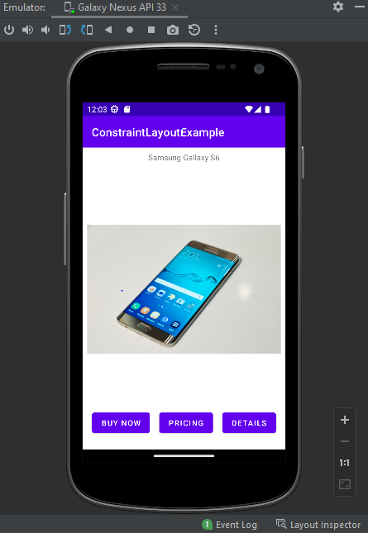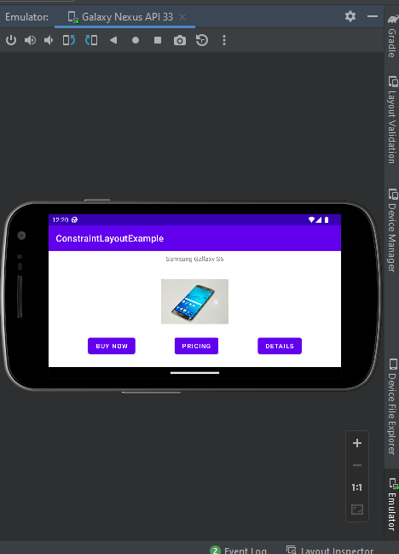

* **In this work we use inferring constraints and basic layout design**

**Classwork 2 : Ferry Ticket App**

* **Xml file :**

<?xml version="1.0" encoding="utf-8"?>  
<androidx.constraintlayout.widget.ConstraintLayout xmlns:android="http://schemas.android.com/apk/res/android"  
 xmlns:app="http://schemas.android.com/apk/res-auto"  
 xmlns:tools="http://schemas.android.com/tools"  
 android:layout_width="match_parent"  
 android:layout_height="match_parent"  
 tools:context=".MainActivity">  
  
  
 <TextView  
 android:id="@+id/textView"  
 android:layout_width="wrap_content"  
 android:layout_height="wrap_content"  
 android:layout_marginTop="16dp"  
 android:text="Catalina Ferry Tickets"  
 android:textAppearance="@style/TextAppearance.AppCompat.Large"  
 app:layout_constraintEnd_toEndOf="parent"  
 app:layout_constraintHorizontal_bias="0.497"  
 app:layout_constraintStart_toStartOf="parent"  
 app:layout_constraintTop_toTopOf="parent" />  
  
 <ImageView  
 android:id="@+id/imageView"  
 android:layout_width="412dp"  
 android:layout_height="223dp"  
 android:layout_marginTop="32dp"  
 app:layout_constraintEnd_toEndOf="parent"  
 app:layout_constraintStart_toStartOf="parent"  
 app:layout_constraintTop_toBottomOf="@+id/textView"  
 app:srcCompat="@drawable/ferry" />  
  
 <EditText  
 android:id="@+id/TicketNum"  
 android:layout_width="wrap_content"  
 android:layout_height="wrap_content"  
 android:layout_marginTop="36dp"  
  
 android:hint="Number of Tickets"  
 android:inputType="number"  
 android:minHeight="48dp"  
 app:layout_constraintEnd_toEndOf="parent"  
 app:layout_constraintHorizontal_bias="0.517"  
 app:layout_constraintStart_toStartOf="parent"  
 app:layout_constraintTop_toBottomOf="@+id/imageView" />  
  
 <Spinner  
 android:id="@+id/spinnerTrip"  
 android:layout_width="329dp"  
 android:layout_height="48dp"  
 android:layout_marginTop="16dp"  
 android:entries="@array/txtTrip"  
 android:spinnerMode="dropdown"  
 app:layout_constraintBottom_toTopOf="@+id/ComputeCost"  
 app:layout_constraintEnd_toEndOf="parent"  
 app:layout_constraintStart_toStartOf="parent"  
 app:layout_constraintTop_toBottomOf="@+id/TicketNum"  
 app:layout_constraintVertical_bias="0.227"  
 tools:ignore="SpeakableTextPresentCheck,SpeakableTextPresentCheck,SpeakableTextPresentCheck" />  
  
 <Button  
 android:id="@+id/ComputeCost"  
 android:layout_width="wrap_content"  
 android:layout_height="wrap_content"  
 android:layout_marginTop="92dp"  
 android:text="Compute Cost"  
 app:layout_constraintEnd_toEndOf="parent"  
 app:layout_constraintHorizontal_bias="0.498"  
 app:layout_constraintStart_toStartOf="parent"  
 app:layout_constraintTop_toBottomOf="@+id/TicketNum" />  
  
 <TextView  
 android:id="@+id/CostOfTrip"  
 android:layout_width="120dp"  
 android:layout_height="42dp"  
 android:text="Cost Of Trip"  
 app:layout_constraintBottom_toBottomOf="parent"  
 app:layout_constraintEnd_toEndOf="parent"  
 app:layout_constraintHorizontal_bias="0.498"  
 app:layout_constraintStart_toStartOf="parent"  
 app:layout_constraintTop_toBottomOf="@+id/ComputeCost"  
 app:layout_constraintVertical_bias="0.158" />  
</androidx.constraintlayout.widget.ConstraintLayout>

* **Image file :**



* **MainActivity file :**

package com.example.myferryticketapp;  
  
import androidx.appcompat.app.AppCompatActivity;  
  
import android.os.Bundle;  
import android.view.View;  
import android.widget.Button;  
import android.widget.EditText;  
import android.widget.Spinner;  
import android.widget.TextView;  
import android.widget.Toast;  
  
import java.text.NumberFormat;  
  
public class MainActivity extends AppCompatActivity {  
  
 double costPerTicketToCatalina=34;  
 double costPerTicketToLongBeach=40;  
 int numberOfTickets;  
 double TotalCost;  
 String tripChoice;  
  
 @Override  
 protected void onCreate(Bundle savedInstanceState) {  
 super.onCreate(savedInstanceState);  
 setContentView(R.layout.*activity_main*);  
  
 EditText Tickets= findViewById(R.id.*TicketNum*);  
 Spinner destination=findViewById(R.id.*spinnerTrip*);  
 TextView result=findViewById(R.id.*CostOfTrip*);  
 Button cost=findViewById(R.id.*ComputeCost*);  
 cost.setOnClickListener(new View.OnClickListener() {  
 @Override  
 public void onClick(View v) {  
 try {  
 numberOfTickets = Integer.*parseInt*(Tickets.getText().toString());  
 }  
 catch(NumberFormatException e) {  
 result.setText("Please enter a valid Number of tickets you need");  
 return;  
 }  
 NumberFormat currency=NumberFormat.*getCurrencyInstance*();  
  
 tripChoice=destination.getSelectedItem().toString();  
 if(destination.getSelectedItemPosition()==0) {  
 TotalCost=costPerTicketToCatalina*numberOfTickets;  
 }  
 else  
 TotalCost=costPerTicketToLongBeach*numberOfTickets;  
  
 result.setText("One Way Trip "+tripChoice+" for "+numberOfTickets+" passengers: "+currency.format(TotalCost));  
 }  
 });  
  
 }  
  
 }  
;

* **String. Xml file :**
* <resources>  
   <string name="app_name">My Ferry Ticket App</string>  
   <string-array name="txtTrip">  
   <item>To Catalina Island</item>  
   <item>To Long Beach</item>  
   </string-array>  
  </resources>
* **Output Result :**

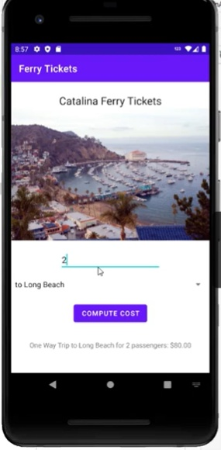

**Classwork 3 : Converter ( view binding)**

* **Xml file :**

<?xml version="1.0" encoding="utf-8"?>  
<androidx.constraintlayout.widget.ConstraintLayout xmlns:android="http://schemas.android.com/apk/res/android"  
 xmlns:app="http://schemas.android.com/apk/res-auto"  
 xmlns:tools="http://schemas.android.com/tools"  
 android:layout_width="match_parent"  
 android:layout_height="match_parent"  
 tools:context=".MainActivity">  
  
 <TextView  
 android:id="@+id/textView"  
 android:layout_width="311dp"  
 android:layout_height="72dp"  
 android:text="Euro Value!"  
 app:layout_constraintBottom_toBottomOf="parent"  
 app:layout_constraintEnd_toEndOf="parent"  
 app:layout_constraintStart_toStartOf="parent"  
 app:layout_constraintTop_toBottomOf="@+id/dollarText"  
 app:layout_constraintVertical_bias="0.181" />  
  
 <EditText  
 android:id="@+id/dollarText"  
 android:layout_width="wrap_content"  
 android:layout_height="wrap_content"  
 android:ems="10"  
 android:inputType="numberDecimal"  
 app:layout_constraintBottom_toBottomOf="@+id/button"  
 app:layout_constraintEnd_toEndOf="parent"  
 app:layout_constraintHorizontal_bias="0.498"  
 app:layout_constraintStart_toStartOf="parent"  
 app:layout_constraintTop_toTopOf="parent"  
 app:layout_constraintVertical_bias="0.395"  
 tools:ignore="speakable"  
 android:autofillHints="" />  
  
 <Button  
 android:id="@+id/button"  
 android:layout_width="wrap_content"  
 android:layout_height="wrap_content"  
 android:layout_marginBottom="248dp"  
 android:onClick="convertCurrency"  
 android:text="Convert"  
 app:layout_constraintBottom_toBottomOf="parent"  
 app:layout_constraintEnd_toEndOf="parent"  
 app:layout_constraintHorizontal_bias="0.498"  
 app:layout_constraintStart_toStartOf="parent" />  
  
</androidx.constraintlayout.widget.ConstraintLayout>

* **Main Activity file :**

package com.example.converter;  
  
import androidx.appcompat.app.AppCompatActivity;  
  
import android.annotation.SuppressLint;  
import android.os.Bundle;  
import android.view.View;  
  
import com.example.converter.databinding.ActivityMainBinding;  
  
import java.util.Locale;  
  
public class MainActivity extends AppCompatActivity {  
 private ActivityMainBinding binding ;  
 @Override  
 protected void onCreate(Bundle savedInstanceState) {  
 super.onCreate(savedInstanceState);  
  
 binding = ActivityMainBinding.*inflate*(getLayoutInflater());  
 View view = binding.getRoot();  
 setContentView(view);  
 }  
  
 @SuppressLint("SetTextI18n")  
 public void convertCurrency(View view) {  
  
 //EditText dollarText = findViewById(R.id.dollarText);  
 //TextView textView = findViewById(R.id.textView);  
  
 if(!binding.dollarText.getText().toString().equals("")){  
  
 float dollarValue = Float.*parseFloat*(binding.dollarText.getText().toString());  
 float euroValue = dollarValue * 0.85F ;  
 binding.textView.setText(String.*format*(Locale.*ENGLISH*, "%.2f", euroValue));  
 }  
 else {  
 binding.textView.setText("No Value");  
 }  
 }  
}

* **Gradle file :**

plugins **{** id 'com.android.application'  
**}**android **{** namespace 'com.example.converter'  
 compileSdk 33  
 buildFeatures **{** viewBinding true  
 **}** defaultConfig **{** applicationId "com.example.converter"  
 minSdk 24  
 targetSdk 33  
 versionCode 1  
 versionName "1.0"  
  
 testInstrumentationRunner "androidx.test.runner.AndroidJUnitRunner"  
 **}** buildTypes **{** release **{** minifyEnabled false  
 proguardFiles getDefaultProguardFile('proguard-android-optimize.txt'), 'proguard-rules.pro'  
 **}  
 }** compileOptions **{** sourceCompatibility JavaVersion.*VERSION_1_8* targetCompatibility JavaVersion.*VERSION_1_8* **}  
}**dependencies **{** implementation 'androidx.appcompat:appcompat:1.6.0'  
 implementation 'com.google.android.material:material:1.5.0'  
 implementation 'androidx.constraintlayout:constraintlayout:2.1.3'  
 testImplementation 'junit:junit:4.13.2'  
 androidTestImplementation 'androidx.test.ext:junit:1.1.3'  
 androidTestImplementation 'androidx.test.espresso:espresso-core:3.4.0'  
**}**

* **Output Result :**

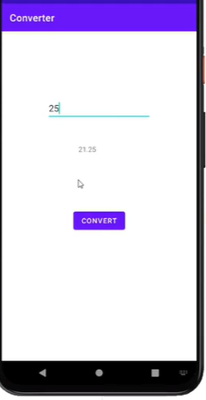

**Explicit View Binding**

* **Main xml :**
* <?xml version="1.0" encoding="utf-8"?>  
  <androidx.constraintlayout.widget.ConstraintLayout xmlns:android="http://schemas.android.com/apk/res/android"  
   xmlns:app="http://schemas.android.com/apk/res-auto"  
   xmlns:tools="http://schemas.android.com/tools"  
   android:layout_width="match_parent"  
   android:layout_height="match_parent"  
   tools:context=".MainActivity">  
    
   <EditText  
   android:id="@+id/EditTextname"  
   android:layout_width="wrap_content"  
   android:layout_height="wrap_content"  
   android:layout_marginTop="133dp"  
   android:layout_marginBottom="103dp"  
   android:ems="10"  
   android:inputType="textPersonName"  
   android:minHeight="48dp"  
   android:text="Name"  
   app:layout_constraintBottom_toTopOf="@+id/textView1"  
   app:layout_constraintEnd_toEndOf="parent"  
   app:layout_constraintHorizontal_bias="0.502"  
   app:layout_constraintStart_toStartOf="parent"  
   app:layout_constraintTop_toTopOf="parent" />  
    
   <TextView  
   android:id="@+id/textView1"  
   android:layout_width="232dp"  
   android:layout_height="49dp"  
   android:layout_marginEnd="1dp"  
   android:layout_marginBottom="93dp"  
   android:text="TextView"  
   app:layout_constraintBottom_toTopOf="@+id/button"  
   app:layout_constraintEnd_toEndOf="@+id/button"  
   app:layout_constraintHorizontal_bias="0.0"  
   app:layout_constraintStart_toStartOf="@+id/EditTextname"  
   app:layout_constraintTop_toBottomOf="@+id/EditTextname" />  
    
   <Button  
   android:id="@+id/button"  
   android:layout_width="157dp"  
   android:layout_height="56dp"  
   android:layout_marginEnd="131dp"  
   android:layout_marginBottom="272dp"  
   android:onClick="SendText"  
   android:text="Send Text"  
   app:layout_constraintBottom_toBottomOf="parent"  
   app:layout_constraintEnd_toEndOf="parent"  
   app:layout_constraintTop_toBottomOf="@+id/textView1" />  
    
  </androidx.constraintlayout.widget.ConstraintLayout>
* **Second xml :**

<?xml version="1.0" encoding="utf-8"?>  
<androidx.constraintlayout.widget.ConstraintLayout xmlns:android="http://schemas.android.com/apk/res/android"  
 xmlns:app="http://schemas.android.com/apk/res-auto"  
 xmlns:tools="http://schemas.android.com/tools"  
 android:layout_width="match_parent"  
 android:layout_height="match_parent"  
 tools:context=".SecondActivity">  
  
 <TextView  
 android:id="@+id/textView2"  
 android:layout_width="wrap_content"  
 android:layout_height="wrap_content"  
 android:layout_marginTop="64dp"  
 android:layout_marginEnd="72dp"  
 android:text="@string/textView"  
 app:layout_constraintEnd_toEndOf="@+id/edittestname2"  
 app:layout_constraintTop_toBottomOf="@+id/edittestname2" />  
  
 <Button  
 android:id="@+id/button2"  
 android:layout_width="wrap_content"  
 android:layout_height="wrap_content"  
 android:layout_marginBottom="261dp"  
 android:text="Return Back"  
 android:onClick="returnBack"  
 app:layout_constraintBottom_toBottomOf="parent"  
 app:layout_constraintEnd_toEndOf="@+id/edittestname2"  
 app:layout_constraintStart_toStartOf="@+id/edittestname2" />  
  
 <EditText  
 android:id="@+id/edittestname2"  
 android:layout_width="wrap_content"  
 android:layout_height="wrap_content"  
 android:layout_marginStart="85dp"  
 android:layout_marginTop="107dp"  
 android:ems="10"  
 android:inputType="textPersonName"  
 android:minHeight="48dp"  
 android:text="Name"  
 app:layout_constraintStart_toStartOf="parent"  
 app:layout_constraintTop_toTopOf="parent" />  
</androidx.constraintlayout.widget.ConstraintLayout>

* **Main activity file :**
* package com.example.explicitviewdemo;  
    
  import androidx.activity.result.ActivityResult;  
  import androidx.activity.result.ActivityResultCallback;  
  import androidx.activity.result.ActivityResultLauncher;  
  import androidx.activity.result.contract.ActivityResultContracts;  
  import androidx.appcompat.app.AppCompatActivity;  
    
  import android.app.Activity;  
  import android.content.Intent;  
  import android.os.Bundle;  
  import android.view.View;  
    
  import com.example.explicitviewdemo.databinding.ActivityMainBinding;  
    
  public class MainActivity extends AppCompatActivity {  
    
   private ActivityMainBinding binding;  
    
    
   @Override  
   protected void onCreate(Bundle savedInstanceState) {  
   super.onCreate(savedInstanceState);  
   binding = ActivityMainBinding.*inflate*(getLayoutInflater());  
   View view=binding.getRoot();  
   // setContentView(R.layout.activity_main);  
   setContentView(view);  
    
   }  
    
   public void SendText(View view){  
   Intent i=new Intent(this,SecondActivity.class);  
   String myString=binding.EditTextname.getText().toString();  
   i.putExtra("qString",myString);  
   //startActivity(i);  
   startForResult.launch(i);;  
   }  
    
   ActivityResultLauncher<Intent> startForResult= registerForActivityResult(  
   new ActivityResultContracts.StartActivityForResult(),  
   new ActivityResultCallback<ActivityResult>() {  
   @Override  
   public void onActivityResult(ActivityResult result) {  
   if (result.getResultCode() == Activity.*RESULT_OK*){  
   Intent data=result.getData();  
   String returnString= data.getExtras().getString("returnData");  
   binding.textView1.setText(returnString);  
   }  
   }  
   }  
   );  
  }
* **Second activity file :**

package com.example.explicitviewdemo;  
  
import androidx.appcompat.app.AppCompatActivity;  
  
import android.content.Intent;  
import android.os.Bundle;  
import android.view.View;  
  
import com.example.explicitviewdemo.databinding.ActivityMainBinding;  
import com.example.explicitviewdemo.databinding.ActivitySecondBinding;  
  
public class SecondActivity extends AppCompatActivity {  
  
 private ActivitySecondBinding binding;  
 @Override  
 protected void onCreate(Bundle savedInstanceState) {  
 super.onCreate(savedInstanceState);  
  
 binding = ActivitySecondBinding.*inflate*(getLayoutInflater());  
 View view=binding.getRoot();  
 setContentView(view);  
 // setContentView(R.layout.activity_second);  
  
 Bundle extra = getIntent().getExtras();  
 if(extra==null){  
 return;  
 }  
 String qstring=extra.getString("qString");  
 binding.textView2.setText(qstring);  
 }  
 public void returnBack(View view){  
 finish();  
 }  
 @Override  
 public void finish(){  
 Intent data= new Intent();  
 String returnString=binding.edittestname2.getText().toString();  
 data.putExtra("returnData",returnString);  
 setResult(*RESULT_OK*,data);  
 super.finish();  
 }  
}

* **Gradle file :**
* plugins **{** id 'com.android.application'  
  **}**android **{** namespace 'com.example.explicitviewdemo'  
   compileSdk 33  
    
   buildFeatures**{** viewBinding true  
   **}** defaultConfig **{** applicationId "com.example.explicitviewdemo"  
   minSdk 24  
   targetSdk 33  
   versionCode 1  
   versionName "1.0"  
    
   testInstrumentationRunner "androidx.test.runner.AndroidJUnitRunner"  
   **}** buildTypes **{** release **{** minifyEnabled false  
   proguardFiles getDefaultProguardFile('proguard-android-optimize.txt'), 'proguard-rules.pro'  
   **}  
   }** compileOptions **{** sourceCompatibility JavaVersion.*VERSION_1_8* targetCompatibility JavaVersion.*VERSION_1_8* **}  
  }**dependencies **{** implementation 'androidx.appcompat:appcompat:1.6.0'  
   implementation 'com.google.android.material:material:1.7.0'  
   implementation 'androidx.constraintlayout:constraintlayout:2.1.4'  
   testImplementation 'junit:junit:4.13.2'  
   androidTestImplementation 'androidx.test.ext:junit:1.1.5'  
   androidTestImplementation 'androidx.test.espresso:espresso-core:3.5.1'  
  **}**
* **output result :**

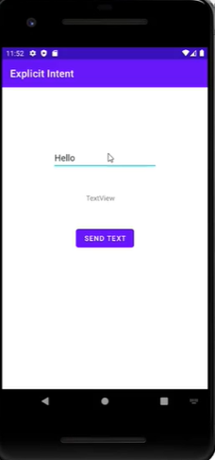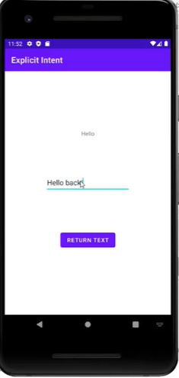

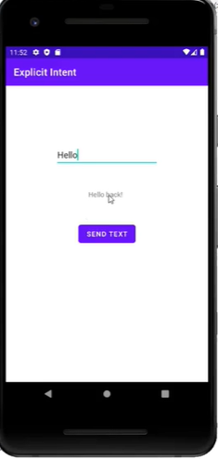

**Classwork 4 : Impicit intent view binding**

* **xml file :**

<?xml version="1.0" encoding="utf-8"?>  
<androidx.constraintlayout.widget.ConstraintLayout xmlns:android="http://schemas.android.com/apk/res/android"  
 xmlns:app="http://schemas.android.com/apk/res-auto"  
 xmlns:tools="http://schemas.android.com/tools"  
 android:layout_width="match_parent"  
 android:layout_height="match_parent"  
 tools:context=".MainActivity">  
  
 <Button  
 android:id="@+id/button"  
 android:layout_width="208dp"  
 android:layout_height="63dp"  
 android:layout_marginBottom="267dp"  
 android:text="Show Web page"  
 android:onClick="ShowWebPage"  
 app:layout_constraintBottom_toBottomOf="parent"  
 app:layout_constraintEnd_toEndOf="parent"  
 app:layout_constraintStart_toStartOf="parent" />  
</androidx.constraintlayout.widget.ConstraintLayout>

* **main activity file :**

package com.example.implicitintent;  
  
import androidx.appcompat.app.AppCompatActivity;  
  
import android.content.Intent;  
import android.net.Uri;  
import android.os.Bundle;  
import android.view.View;  
  
public class MainActivity extends AppCompatActivity {  
  
 @Override  
 protected void onCreate(Bundle savedInstanceState) {  
 super.onCreate(savedInstanceState);  
 setContentView(R.layout.activity_main);  
 }  
  
 public void ShowWebPage(View view){  
 Intent intent=new Intent(Intent.ACTION_VIEW, Uri.parse("https://www.msn.com"));  
 startActivity(intent);  
 }  
}

**By Web view intent binding :**

* **Xml file :**

<?xml version="1.0" encoding="utf-8"?>  
<androidx.constraintlayout.widget.ConstraintLayout xmlns:android="http://schemas.android.com/apk/res/android"  
 xmlns:app="http://schemas.android.com/apk/res-auto"  
 xmlns:tools="http://schemas.android.com/tools"  
 android:layout_width="match_parent"  
 android:layout_height="match_parent"  
 tools:context=".MainActivity">  
  
 <WebView  
 android:id="@+id/webView1"  
 android:layout_width="0dp"  
 android:layout_height="0dp"  
 android:layout_marginStart="1dp"  
 android:layout_marginTop="1dp"  
 android:layout_marginEnd="1dp"  
 android:layout_marginBottom="1dp"  
 app:layout_constraintBottom_toBottomOf="parent"  
 app:layout_constraintEnd_toEndOf="parent"  
 app:layout_constraintStart_toStartOf="parent"  
 app:layout_constraintTop_toTopOf="parent" />  
</androidx.constraintlayout.widget.ConstraintLayout>

* **Main activity file :**

package com.example.mywebview;  
  
import androidx.appcompat.app.AppCompatActivity;  
  
import android.content.Intent;  
import android.net.Uri;  
import android.os.Bundle;  
import android.view.View;  
  
import com.example.mywebview.databinding.ActivityMainBinding;  
  
import java.net.URL;  
  
public class MainActivity extends AppCompatActivity {  
  
 private ActivityMainBinding binding;  
 @Override  
 protected void onCreate(Bundle savedInstanceState) {  
 super.onCreate(savedInstanceState);  
  
 binding = ActivityMainBinding.inflate(getLayoutInflater());  
 View view =binding.getRoot();  
 setContentView(view);  
 handleIntent();  
 }  
 private void handleIntent(){  
 Intent intent=getIntent();  
  
 Uri data=intent.getData();  
 URL url=null;  
 try{  
 url= new URL (data.getScheme(),data.getHost(),data.getPath());  
  
 }  
 catch(Exception e){  
 e.printStackTrace();  
 }  
 binding.webView1.loadUrl((url.toString()));  
  
 }  
}

* **Manifest file :**

<?xml version="1.0" encoding="utf-8"?>  
<manifest xmlns:android="http://schemas.android.com/apk/res/android"  
 xmlns:tools="http://schemas.android.com/tools">  
  
 <uses-permission android:name="android.permission.INTERNET"></uses-permission>  
 <application  
 android:allowBackup="true"  
 android:dataExtractionRules="@xml/data_extraction_rules"  
 android:fullBackupContent="@xml/backup_rules"  
 android:icon="@mipmap/ic_launcher"  
 android:label="@string/app_name"  
 android:roundIcon="@mipmap/ic_launcher_round"  
 android:supportsRtl="true"  
 android:theme="@style/Theme.MyWebView"  
 tools:targetApi="31">  
 <activity  
 android:name=".MainActivity"  
 android:exported="true">  
 <intent-filter>  
 <action android:name="android.intent.action.VIEW"></action>  
 <category android:name="android.intent.category.BROWSABLE"></category>  
 <category android:name="android.intent.category.DEFAULT"></category>  
 <data android:scheme="https" android:host="www.msn.com"></data>  
 </intent-filter>  
  
 <meta-data  
 android:name="android.app.lib_name"  
 android:value="" />  
 </activity>  
 </application>  
  
</manifest>

* **Build gradle file :**
* plugins **{** id 'com.android.application'  
  **}**android **{** namespace 'com.example.mywebview'  
   compileSdk 32  
    
   buildFeatures **{** viewBinding true  
   **}** defaultConfig **{** applicationId "com.example.mywebview"  
   minSdk 21  
   targetSdk 32  
   versionCode 1  
   versionName "1.0"  
    
   testInstrumentationRunner "androidx.test.runner.AndroidJUnitRunner"  
   **}** buildTypes **{** release **{** minifyEnabled false  
   proguardFiles getDefaultProguardFile('proguard-android-optimize.txt'), 'proguard-rules.pro'  
   **}  
   }** compileOptions **{** sourceCompatibility JavaVersion.VERSION_1_8  
   targetCompatibility JavaVersion.VERSION_1_8  
   **}  
  }**dependencies **{** implementation 'androidx.appcompat:appcompat:1.5.1'  
   implementation 'com.google.android.material:material:1.7.0'  
   implementation 'androidx.constraintlayout:constraintlayout:2.1.4'  
   testImplementation 'junit:junit:4.13.2'  
   androidTestImplementation 'androidx.test.ext:junit:1.1.3'  
   androidTestImplementation 'androidx.test.espresso:espresso-core:3.4.0'  
  **}**
* **output result :**

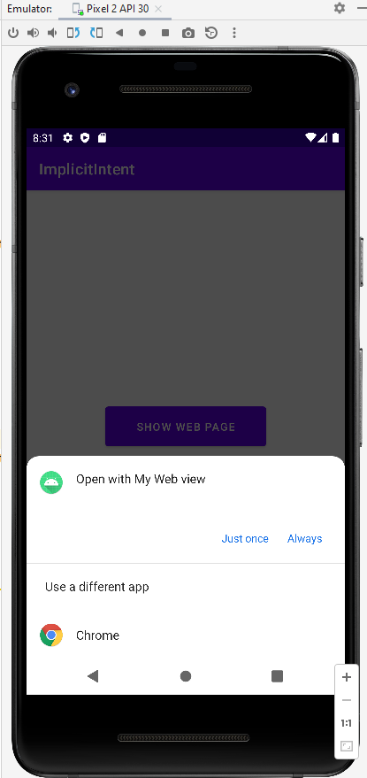

**Classwork 5: Broadcast**

* **Xml File :**
* *<?***xml version="1.0" encoding="utf-8"***?>*<**androidx.constraintlayout.widget.ConstraintLayout xmlns:android="http://schemas.android.com/apk/res/android"  
   xmlns:app="http://schemas.android.com/apk/res-auto"  
   xmlns:tools="http://schemas.android.com/tools"  
   android:layout_width="match_parent"  
   android:layout_height="match_parent"  
   tools:context=".MainActivity"**>  
    
   <**Button  
   android:id="@+id/button"  
   android:layout_width="wrap_content"  
   android:layout_height="wrap_content"  
   android:layout_marginEnd="120dp"  
   android:text="Send Broadcast"  
   android:onClick="BroadCastIntent"  
   app:layout_constraintBottom_toBottomOf="parent"  
   app:layout_constraintEnd_toEndOf="parent"  
   app:layout_constraintTop_toTopOf="parent"  
   app:layout_constraintVertical_bias="0.499"  
   tools:ignore="HardcodedText"** />  
  </**androidx.constraintlayout.widget.ConstraintLayout**>
* **Java files :** 
  + - * + **MainActivity File :**

**package** com.example.sendbroadcast;  
  
**import** androidx.appcompat.app.AppCompatActivity;  
  
**import** android.content.BroadcastReceiver;  
**import** android.content.Intent;  
**import** android.content.IntentFilter;  
**import** android.os.Bundle;  
**import** android.view.View;  
  
**public class** MainActivity **extends** AppCompatActivity {  
  
 BroadcastReceiver receiver;  
  
 @Override  
 **protected void** onCreate(Bundle savedInstanceState) {  
 **super**.onCreate(savedInstanceState);  
 setContentView(R.layout.activity_main);  
 configureReceiver();  
 }  
  
 **private void** configureReceiver(){  
 IntentFilter filter=**new** IntentFilter();  
 filter.addAction(**"com.example.sendbroadcast"**);  
 filter.addAction(**"android.intent.action.ACTION_POWER_DISCONNECTED"**);  
 receiver=**new** MyReceiver();  
 registerReceiver(receiver,filter);  
 }  
 **public void** BroadCastIntent(View view){  
 Intent intent =**new** Intent();  
 intent.setAction(**"com.example.sendbroadcast"**);  
 intent.addFlags(intent.FLAG_INCLUDE_STOPPED_PACKAGES);  
 sendBroadcast(intent);  
 }  
 **protected void** OnDestroy(){  
 **super**.onDestroy();  
 unregisterReceiver(receiver);  
 }  
}

* + - * **MyReceiver file : (Class file )**

**package** com.example.sendbroadcast;  
  
**import** android.content.BroadcastReceiver;  
**import** android.content.Context;  
**import** android.content.Intent;  
**import** android.widget.Toast;  
  
**public class** MyReceiver **extends** BroadcastReceiver {  
  
 @Override  
 **public void** onReceive(Context context, Intent intent) {  
 String messege=**"Broadcast intent detected"**+intent.getAction();  
 Toast.makeText(context,messege,Toast.LENGTH_LONG).show();  
  
 }  
}

* **Menifest file :**
* *<?***xml version="1.0" encoding="utf-8"***?>*<**manifest xmlns:android="http://schemas.android.com/apk/res/android"  
   xmlns:tools="http://schemas.android.com/tools"** >  
    
   <**application  
   android:allowBackup="true"  
   android:dataExtractionRules="@xml/data_extraction_rules"  
   android:fullBackupContent="@xml/backup_rules"  
   android:icon="@mipmap/ic_launcher"  
   android:label="@string/app_name"  
   android:supportsRtl="true"  
   android:theme="@style/Theme.SendBroadcast"  
   tools:targetApi="31"** >  
   <**receiver  
   android:name=".MyReceiver"  
   android:enabled="true"  
   android:exported="true"** >  
   </**receiver**>  
    
   <**activity  
   android:name=".MainActivity"  
   android:exported="true"** >  
   <**intent-filter**>  
   <**action android:name="android.intent.action.MAIN"** />  
    
   <**category android:name="android.intent.category.LAUNCHER"** />  
   </**intent-filter**>  
   </**activity**>  
   </**application**>  
    
  </**manifest**>
  + - **Build Gradle file :**

plugins **{** id **'com.android.application'  
}**android **{** namespace **'com.example.sendbroadcast'** compileSdk 33  
  
 defaultConfig **{** applicationId **"com.example.sendbroadcast"** minSdk 24  
 targetSdk 33  
 versionCode 1  
 versionName **"1.0"** testInstrumentationRunner **"androidx.test.runner.AndroidJUnitRunner"  
 }** buildTypes **{** release **{** minifyEnabled **false** proguardFiles getDefaultProguardFile(**'proguard-android-optimize.txt'**), **'proguard-rules.pro'  
 }  
 }** compileOptions **{** sourceCompatibility JavaVersion.VERSION_1_8  
 targetCompatibility JavaVersion.VERSION_1_8  
 **}  
}**dependencies **{** implementation **'androidx.appcompat:appcompat:1.4.1'** implementation **'com.google.android.material:material:1.5.0'** implementation **'androidx.constraintlayout:constraintlayout:2.1.3'** testImplementation **'junit:junit:4.13.2'** androidTestImplementation **'androidx.test.ext:junit:1.1.3'** androidTestImplementation **'androidx.test.espresso:espresso-core:3.4.0'  
}**

* **Output Results :**

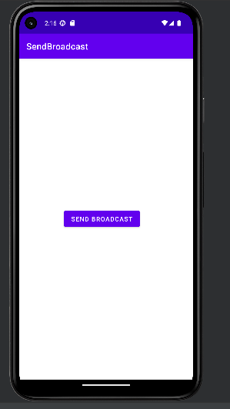

***Output ScreenShot:***

